Scottish Housing Day
15 September 2021:
Supporters Activity Pack

1. Overview

It’s back! Scottish Housing Day is about celebrating the impact that housing makes to the lives of people and communities across the country, as well as communicating to people about their housing options. This year we are encouraging people to think about the role of housing in tackling the climate emergency, to share stories about successful projects and signpost tenants and homeowners to sources of advice, information and support.

We want every one of you to get involved, to raise awareness of the great work taking place in the housing sector, and to better inform the public about the role of housing in tackling the climate emergency.

2. How you can get involved

The day will be driven by social media, political engagement and local activity.

If you are involved in any activity, event, visit or issue relating to housing and the climate emergency then let us know on Twitter by using the hashtag #scottishhousingday.

Last year housing organisations across the country took part by
- Holding their AGM on the day
- Having a (virtual) coffee morning with tenants
- Organising debates and discussions
- Asking questions as part of twitter debates
- Writing blogs
- Opening new housing developments
- Meeting local officials

There really is no limit to how you can get involved but we have detailed some ideas below to get you started.
Source: Twitter
2.1 Sign up

The first and most important thing you can do is sign up as a supporter. And once you have done this you can download the following Scottish Housing Day branding on the resources page of the Scottish Housing Day website:
- Email signature
- Save the Date poster
- Twibbon

You can also sign up to show your support on the ‘Show your support’ page.
2.2 Social Media
We want to hear about what you and your organisation are doing day in day out to help your tenants and customers. Alongside this campaign pack, you will find branded A4 cards on the Scottish Housing day website to print off and write on. We want everyone to tell their organisation’s story and share these via social media.

You can use these to share why you think reducing carbon emissions is important or what you as an individual or your organisation is doing to help tackle the climate emergency.

On 15 September, we want the entire housing sector to take to Twitter and Linkedin and post their stories about the impact that their organisation is making locally.

This could focus on:
- How your organisation is improving the energy efficiency of homes or making use of zero carbon technologies.
- How you are supporting tenants or residents to reduce energy use in their homes.
- How your organisation is delivering new zero carbon homes.
- Local projects raising awareness of or tackling climate change in the community. These could include reducing food waste, supporting local sharing or re-using projects or, community gardens and active travel.
- Tenant or resident stories and experiences of living with low or zero carbon heating systems.

Remember – examples can include simple changes, they really can make a big difference!
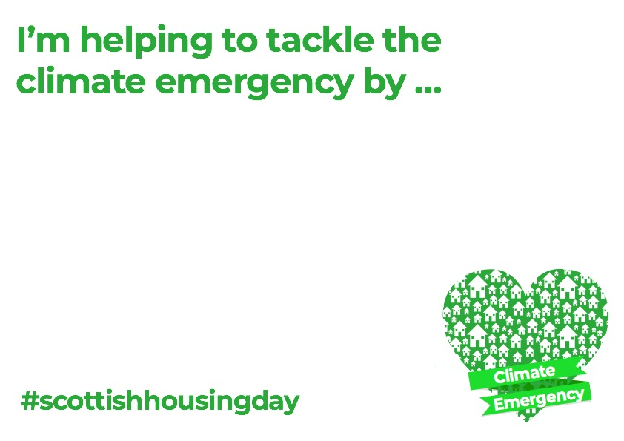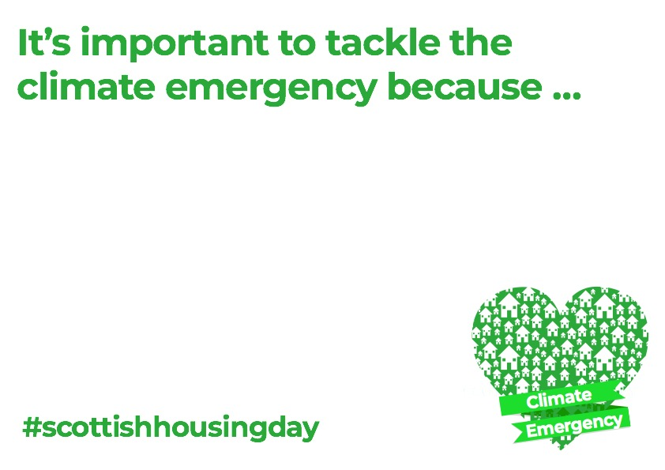
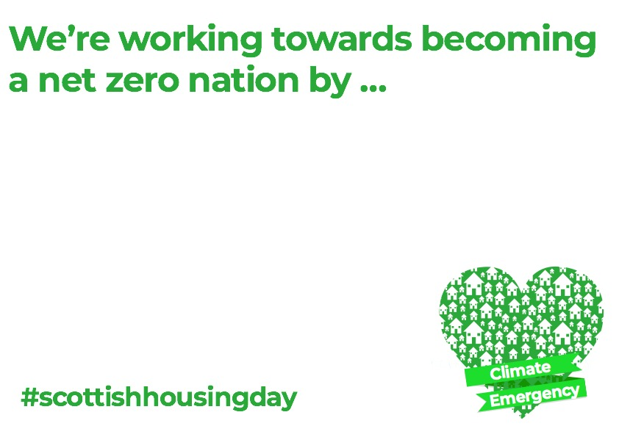
But you don’t need to wait until Scottish Housing Day on 15 September to get involved - we want you to start tweeting, posting and sharing your support for Scottish Housing Day today and we want everyone to be talking about housing day come 15 September.

2.3 Holding an event
We want housing associations, tenants’ and residents groups, local authorities, private landlords, letting agents, developers and anyone with an interest in housing to time your team meetings, AGMs or coffee mornings, fun days or events on or around 15 September. If you have something planned already why not use the opportunity to celebrate Scottish Housing Day as well?

Of course Covid-19 guidance means much of this activity may have to be organised in a different way but you can use video conferencing platforms where face to face engagement isn’t possible through Teams, Zoom or other platforms to meet with your members/tenants and support Scottish Housing Day.

Once you have arranged your event, please let us know by emailing Ashley Campbell, Policy and practice manager at CIH Scotland ashley.campbell@cih.org and we will help to promote your activity.

2.4 Write a blog
We want to hear your housing story and your thoughts on the role of the housing sector in tackling the climate emergency. What are we getting right and what could we be doing better?

Why not write a short 300 -500 word blog and we’ll post this on the Scottish Housing Day website and share with our followers. Some ideas include:
- What is your view on the role of the housing sector in tackling the climate emergency?
- How do we ensure that tenants and homeowners get the advice and financial support needed to meet carbon reduction targets?
- What is your organisation doing to tackle the climate emergency and how are you involving tenants, customers or residents?
- What are tenants and residents groups doing to help tackle the climate emergency?

Send your blogs to Tom.Gorham@gov.scot

2.6 Attend an event
We will be holding an online event on Scottish Housing Day to celebrate the day and we want you to take part.

Further details and places for the event will become available in the summer but if you would like to note your interest in attending please contact Tom.Gorham@gov.scot or ashley.campbell@cih.org

3. Key contacts

Ashley Campbell
Policy and Practice Manager
CIH Scotland
Ashley.campbell@cih.org

Tom Gorham
Scottish Government
Tom.Gorham@gov.scot

APPENDIX

- DRAFT MEDIA RELEASE

{TITLE OF RELEASE]
Media contact: [YOUR GROUP WILL NEED A DESIGNATED CONTACT]
Telephone: [LAND-LINE NUMBER AND/OR MOBILE NUMBER – make sure your contact is available on one or both numbers between 8am and 8pm for at least a couple of days after you send the release]
For Immediate Release: [DATE]

XXXX hold event to celebrate Scottish Housing Day in [NAME OF AREA]

On [ENTER DATE] [NAME OF GROUP] will hold an event in [NAME OF AREA] to celebrate Scottish Housing Day. The group has [DETAIL OF WHAT THE EVENT INVOLVES AND ITS PURPOSE]

Scottish Housing Day is about celebrating the impact that housing makes to the lives of people and communities across the country as well as communicating to people what their housing options are. This year, it also focusses on the role of housing in tackling the climate emergency.

Meeting at [TIME AND VENUE], they will [SHORT DESCRIPTION THE EVENT].

[QUOTE 1: A GROUP MEMBER – Saying why they got involved and what why housing matters]

[QUOTE 2: CIH Scotland – Get in touch with us and we’ll be happy to give you a quote. Email Ashley Campbell, Policy and practice manager ashley.campbell@cih.org]

Ends

